**Dynamic Routing (For three computer)**

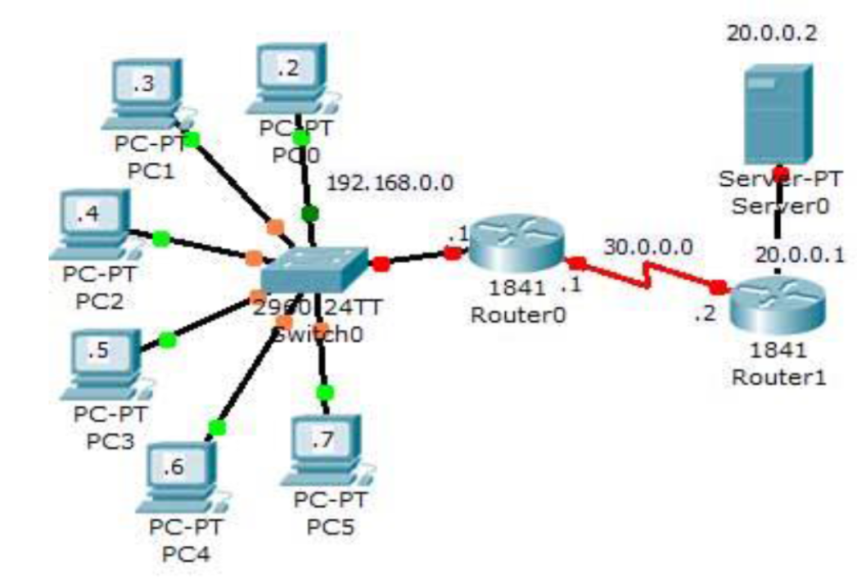

**For router 0 (CLI):**

--- System Configuration Dialog ---

Would you like to enter the initial configuration dialog? [yes/no]: no

Press RETURN to get started!

Router>enable

Router#conf t

Enter configuration commands, one per line. End with CNTL/Z.

Router(config)#hostname R1

R1(config)#int fa0/0

R1(config-if)#ip add 192.168.0.1 255.255.255.0

R1(config-if)#no shut

R1(config-if)#

%LINK-5-CHANGED: Interface FastEthernet0/0, changed state to up

%LINEPROTO-5-UPDOWN: Line protocol on Interface FastEthernet0/0, changed state to up

R1(config-if)#exit

R1(config)#interface serial 0/0/0

R1(config-if)#ip add 30.0.0.1 255.0.0.0

R1(config-if)#clock rate 64000

R1(config-if)#bandwidth 64

R1(config-if)#so shut

%LINK-5-CHANGED: Interface Serial0/0/0, changed state to down

R1(config-if)#exit

R1(config)#ip route 0.0.0.0 0.0.0.0 serial 0/0/0

R1(config)#access-list 1 permit 192.168.0.0 0.0.0.225

R1(config)#ip nat pool test 50.0.0.1 50.0.0.6 netmask 255.0.0.0

R1(config)#ip nat inside source list 1 pool test

R1(config)#int fa0/0

R1(config-if)#ip nat inside

R1(config-if)#exit

R1(config)#interface serial 0/0/0

R1(config-if)#ip nat outside

R1(config-if)#exit

R1(config)#exit

R1#

%SYS-5-CONFIG_I: Configured from console by console

%LINK-5-CHANGED: Interface Serial0/0/0, changed state to up

%LINEPROTO-5-UPDOWN: Line protocol on Interface Serial0/0/0, changed state to up

R1#

R1#conf t

Enter configuration commands, one per line. End with CNTL/Z.

R1(config)#access-list 1 permit 192.168.0.4 0.0.0.0

R1(config)#access-list 1 permit 192.168.0.3 0.0.0.0

R1(config)#access-list 1 deny any

R1(config)#exit

R1#

%SYS-5-CONFIG_I: Configured from console by console

R1#

For Router 1:

Press RETURN to get started.

For router 1(CLI):

--- System Configuration Dialog ---

Would you like to enter the initial configuration dialog? [yes/no]: no

Press RETURN to get started!

Router>enable

Router#conf t

Enter configuration commands, one per line. End with CNTL/Z.

Router(config)#int fa0/0

Router(config-if)#ip add 20.0.0.1 255.0.0.0

Router(config-if)#no shut

Router(config-if)#

%LINK-5-CHANGED: Interface FastEthernet0/0, changed state to up

%LINEPROTO-5-UPDOWN: Line protocol on Interface FastEthernet0/0, changed state to up

Router(config-if)#exit

Router(config)#interface serial 0/0/0

Router(config-if)#ip add 30.0.0.2 255.0.0.0

Router(config-if)#no shut

Router(config-if)#

%LINK-5-CHANGED: Interface Serial0/0/0, changed state to up

Router(config-if)#exit

Router(config)#ip rout

%LINEPROTO-5-UPDOWN: Line protocol on Interface Serial0/0/0, changed state

Router(config)#ip route 0.0.0.0 0.0.0.0 serial 0/0/0

Router(config)#hostname R2

R2(config)#

R2 con0 is now available

**Press RETURN to get started.**